<https://www.youtube.com/watch?v=rnfHuWneMXA>

webstorm

<https://www.youtube.com/watch?v=tWa6RtwQw-Y>

<https://www.youtube.com/watch?v=nHjKXiRLAQY>

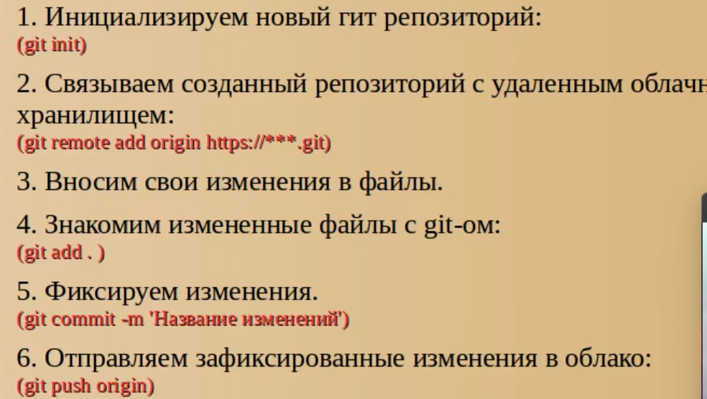

git push origin master ()

git push origin ветка

